**Illustrative model-based analysis of vaccination and release strategies (Scotland) - Update**

Mark Woolhouse, Alex Morgan & Bram van Bunnik

University of Edinburgh

04/05/21

Summary

This analysis is an update of the briefing report ‘Illustrative model-based analysis of vaccination and release strategies (Scotland)’ submitted to SPI-M on 05/01/21. All methods, including model structure are unchanged.

The original report drew three main conclusions:

* High confidence of a decrease in the incidence of high-risk infections (=those in unvaccinated vulnerable individuals) over the first 90 days of 2021
* High confidence of a significant surge in high-risk infections following full release of restrictions after the nine JCVI priority groups had been vaccinated
* Very high uncertainty of epidemic trajectory in the second half of the year

This update explores the following combinations of parameter values:

* 95% coverage, noting this is above the previous range (50-90%)
* 50% protection against infection (previous range 50-90%)
* 50% reduction in onward transmission (previous range 50-90%)
* Roll-out rate assumes two-thirds coverage by June 29th (day 180)

Key results are:

* Confirms that relaxing restrictions immediately after the nine highest priority groups had been vaccinated could have resulted in a major wave
* No other scenario now generates a major wave within one year
* A minor wave after full release of restrictions at day 180 is not expected if vaccine roll-out continues at current pace
* A major wave beginning in the 3rd quarter of 2021 remains possible *if* vaccine roll-out were discontinued (not government policy)

This exercise was not designed to explore the impact of bringing forward full release to May 17th (day 137) but there is clearly scope for doing so without a significant risk of either overwhelming the NHS or needing to re-impose lockdown over the medium term (=6 months), provided that vaccine roll-out is expected to continue at current pace.

As an earlier release from restrictions could now be a viable policy option we suggest that it is modelled in more detail.

The herd immunity threshold is not reached in these updated scenarios. This means that some degree of resurgence is expected in 2021 or early 2022 unless some countermeasures are retained.

NB. This analysis provides insights in to the complex dynamics of a combination of virus spread, the impact of NPIs and vaccine roll out. We use the model to explore different scenarios that shed light on these dynamics over a one-year period. They are not predictions.

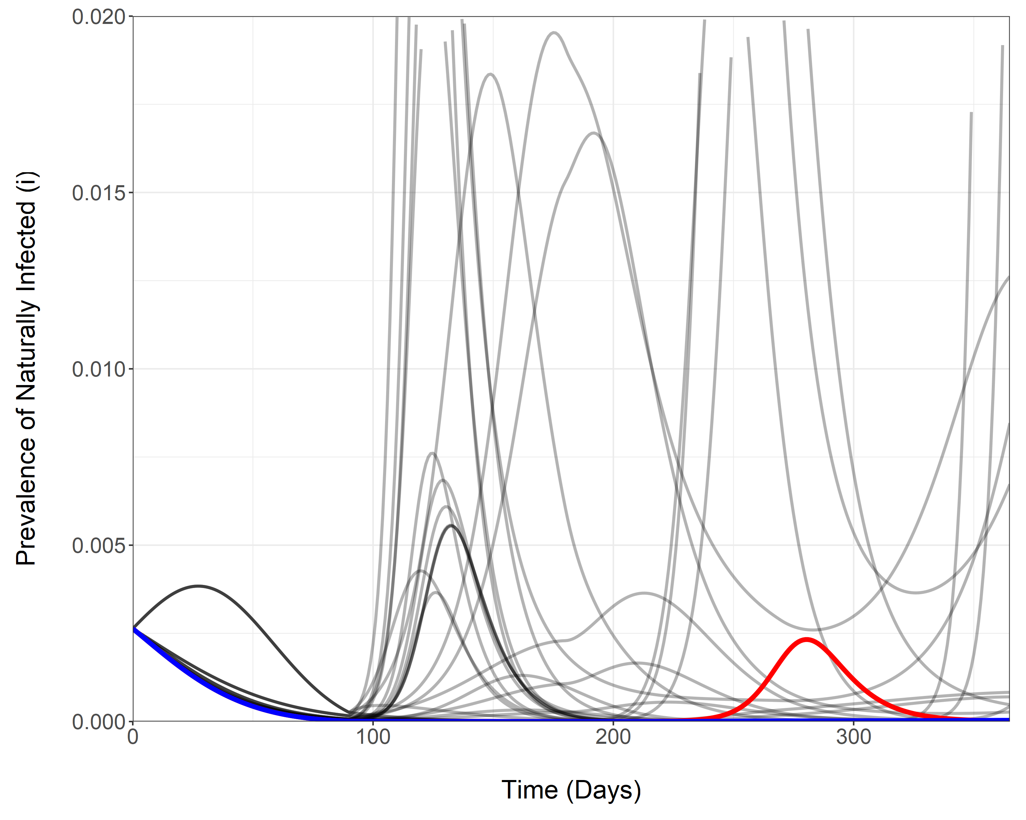

**Figure 1 – Simulated daily prevalence of COVID-19 infection in high risk individuals who have not been vaccinated, belonging to the vulnerable subpopulation (i) across 60 modelled scenarios.** The scenario highlighted in blue represent the baseline scenario (transmission-blocking/infection-preventing efficacy = 50% and subpopulation vaccine coverage = 95%) and in red is the same but with discontinued vaccination on day 180. All other scenarios in grey represent sensitivity analyses relating to previously modelled parameter combinations. These may overlap.